Lab 6: Dynamic Routing with OSPF

Contents

Introduction to LAB 6 2

Exercise 1: Create a layer 3 network with multiple paths to the destination 2

Exercise 2: Create a single area OSPF 5

Exercise 3: Configure passive interfaces 12

Useful commands for checking your configurations and troubleshooting 13

# Introduction to LAB 6

In the previous lab, you practiced different options for direct and static routing configuration. Now, you will learn how to configure basic OSPF in a single area and will see the benefits of the dynamic routing.

# Exercise 1: Create a layer 3 network with multiple paths to the destination

1. Create the physical topology.

Open the packet tracer and move the following devices into the workspace:

* Five routers (2911)
* Two switches (2960)
* Two laptops (end devices, generic)

Rename the devices so the numbering starts from 1 and connect them as per the picture below. Also, remember to enable the interfaces in the routers since they are disabled by default. (The IP addressing will be explained in the next step)

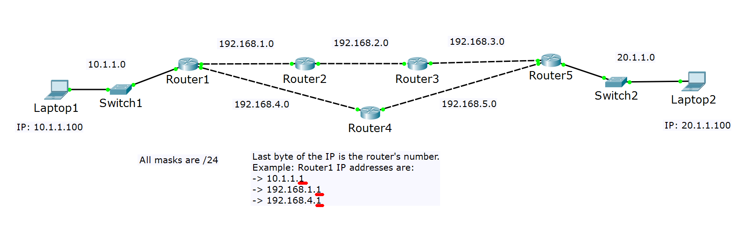

1. Assign the IP addresses.

In this topology, we have multiple IP networks. As you already know, each of these networks represent a separate broadcast domain and we can say that each IP network is assigned to a different router’s port. The routers which are connected directly to each other share one network (or IP subnet).

In the picture above, you can see the different IP networks (they are seven) which you will use. Please note the following explanations about the IP addressing convention:

* All of the networks and IP addresses have /24 subnet masks
* The switches will not have IP addresses
* The end devices IP addresses are:
* Laptop1: 10.1.1.100
* Laptop2: 20.1.1.100
* The exact IP address on a router’s port has the router’s number in the last octet (byte).

Example for Router1 IP addresses:

* 10.1.1.1
* 192.168.1.1
* 192.168.4.1

Example for Router2 IP addresses:

* 192.168.1.2
* 192.168.2.2

With this in mind, you can only use the picture above to assign all the IP addresses. For more clearness, in the table below you will see the all IP address assignments for each interface.

Note: You can have different interface numbers/names in your topologies and that is why exact interface names are not mentioned here (like gigabitEthernet 0/0, for example). Instead, we use the “port-to-device” approach which clearly defines it.

|  |  |  |
| --- | --- | --- |
| Device/Port | IP Address | Belongs to network (informational only) |
| Laptop1 | 10.1.1.100 | 10.1.1.0 |
| Router1/port-to-Switch1 | 10.1.1.1 | 10.1.1.0 |
| Router1/port-to-Router2 | 192.168.1.1 | 192.168.1.0 |
| Router1/port-to-Router4 | 192.168.4.1 | 192.168.4.0 |
| Router2/port-to-Router1 | 192.168.1.2 | 192.168.1.0 |
| Router2/port-to-Router3 | 192.168.2.2 | 192.168.2.0 |
| Router3/port-to-Router2 | 192.168.2.3 | 192.168.2.0 |
| Router3/port-to-Router5 | 192.168.3.3 | 192.168.3.0 |
| Router4/port-to-Router1 | 192.168.4.4 | 192.168.4.0 |
| Router4/port-to-Router5 | 192.168.5.4 | 192.168.5.0 |
| Router5/port-to-Router3 | 192.168.3.5 | 192.168.3.0 |
| Router5/port-to-Router4 | 192.168.5.5 | 192.168.5.0 |
| Router5/port-to-Switch2 | 20.1.1.5 | 20.1.1.0 |
| Laptop2 | 20.1.1.100 | 20.1.1.0 |

To check that your addresses are assigned correctly and all the interfaces are enabled, test your setup by pinging the directly connected devices from each router.

For example, from Router1, ping these addresses:

* 10.1.1.100 (Laptop1)
* 192.168.1.2 (Router2)
* 192.168.4.4 (Router4)

All the pings should be successful. If you have somewhere unsuccessful ping, check the connections, the IP addresses and if the interfaces are enabled.

Note: Remember that you may see the first one or two ICMP packets lost. This is because of the ARP process which happens in the background.

# Exercise 2: Create a single area OSPF

You now have a routing topology and the next step is to enable OSPF. You will use single area, area 0, so all the routers learn dynamically from each other for the whole network.

1. Enable the interfaces for OSPF and advertise the networks

For each router, you will need to enable OSPF (use process 1 everywhere) and advertise the networks that it has.

Also, you will manually setup a router id with the following convention:

* Router1 -> 1.1.1.1
* Router2 -> 2.2.2.2
* Router3 -> 3.3.3.3
* Router4 -> 4.4.4.4
* Router5 -> 5.5.5.5

This step is optional since each device will automatically select a router id but setting this up manually will give you more clear idea about the OSPF process – you can see the neighbors easier.

Here are the configurations that you need to do (from global configuration mode for the routers) for each device:

**Router1:**

**router ospf 1**

**router-id 1.1.1.1**

**network 10.1.1.0 0.0.0.255 area 0**

**network 192.168.1.0 0.0.0.255 area 0**

**network 192.168.4.0 0.0.0.255 area 0**

**Router2:**

**router ospf 1**

**router-id 2.2.2.2**

**network 192.168.1.0 0.0.0.255 area 0**

**network 192.168.2.0 0.0.0.255 area 0**

**Router3:**

**router ospf 1**

**router-id 3.3.3.3**

**network 192.168.2.0 0.0.0.255 area 0**

**network 192.168.3.0 0.0.0.255 area 0**

**Router4:**

**router ospf 1**

**router-id 4.4.4.4**

**network 192.168.4.0 0.0.0.255 area 0**

**network 192.168.5.0 0.0.0.255 area 0**

**Router5:**

**router ospf 1**

**router-id 5.5.5.5**

**network 192.168.3.0 0.0.0.255 area 0**

**network 20.1.1.0 0.0.0.255 area 0**

Note: At this point you are not advertising (enabling OSPF) for network 192.168.5.0 in Router5. This means that it will not form adjacency with Router4 and therefore they will not exchange their routing tables. This is intentional and you will observe the outcome in a minute.

**Laptop1:**

Set the default gateway to **10.1.1.1**

**Laptop2:**

Set the default gateway to **20.1.1.5**

1. Check the routing topology.

First, try to ping Laptop2 (20.1.1.100) from Laptop1. It should succeed. If not, go back and check all your configurations from the previous steps.

Now you have dynamic routing. But which path the packets take?

Have a look at the routing tables of the devices and see the entries starting with “O” (this is OSPF). In Router1, type **show ip route**

The output should be similar to what is in the screenshot below:

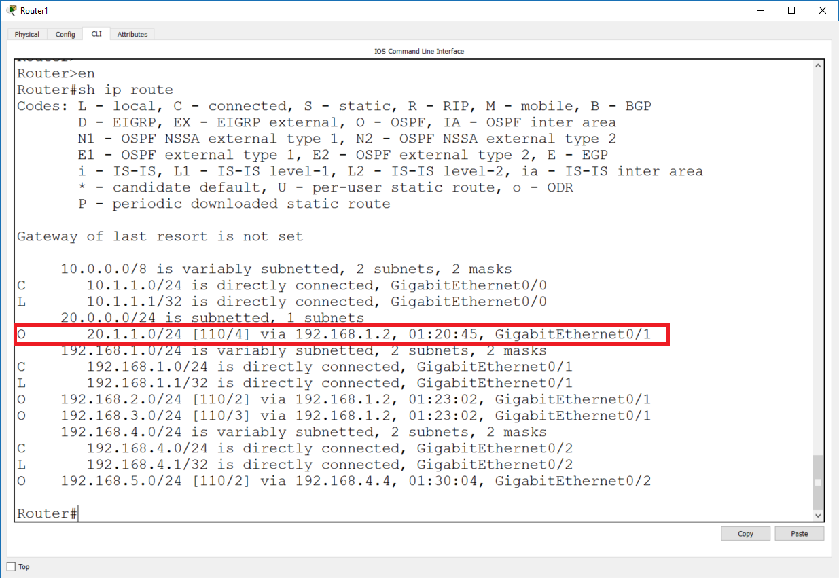

Have a special look at the highlighted entry. It shows that for Router1 to reach 20.1.1.0/24 network, it has to go through 192.168.1.2, which is Router2. Similarly, check the routing table of Router2, Router3 and Router5 and have a look at the entries for 20.1.1.0/24 and 10.1.1.0/24 networks. As you can see, the packets between these (client) networks and in particular between Laptop1 and Laptop2 will take the routing path Laptop1->Router1->Router2->Router3->Router5->Laptop2. The reverse path will be used for the returning packets.

Note: In the highlighted entry, notice the [110/4] section – it shows the administrative distance of OSPF (110) and the cost of reaching this destination (4)

There are two ways to monitor the exact packet path:

1. Open the simulation mode in packet tracer, filter by ICMP and ping Laptop2 from Laptop1

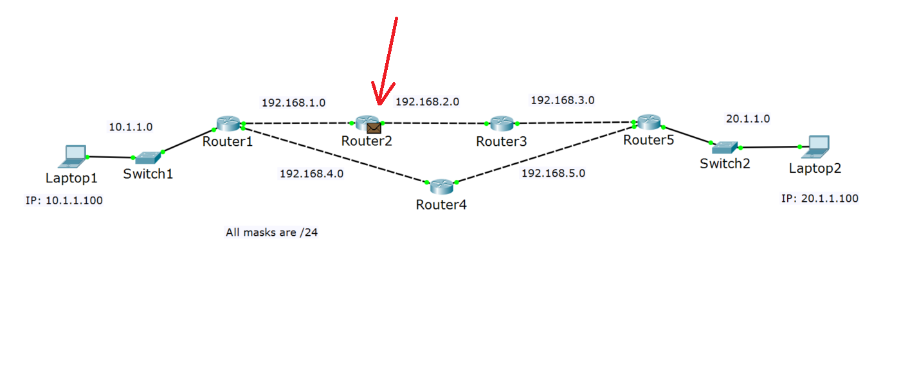

1. Use the traceroute command. From Laptop1 CMD, type **tracert 20.1.1.100**

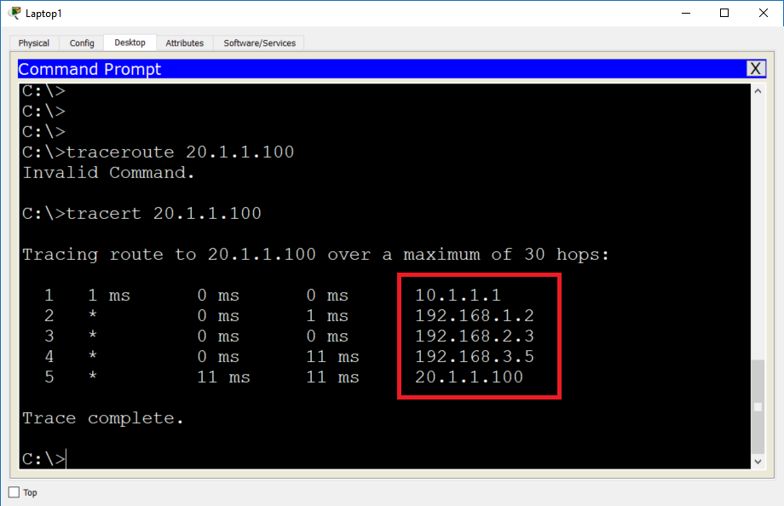

This is how you prove that the packets take exactly this path. It is longer than the other one (via Router4) and this is so because you did not enable the OSPF communication between Router5 and Router4. In the next step, you will fix this.

One more thing that you can check is the OSPF adjacencies or neighbor relations. To do this, in each router type **show ip ospf neighbor**. Observe the result – you will see the Router’s OSPF members with their router ids. Observe the output of this command on Router5 – it should have only 3.3.3.3 (Router3) as a neighbor.

1. Enable OSPF between Router4 and Router5

Router4 already has the 192.168.5.0/24 network advertised and OSPF enabled there. You now need to enabled in on Router5. To do so, add the following configuration from the global config mode:

**Router5:**

**router ospf 1**

**network 192.168.5.0 0.0.0.255 area 0**

1. Check the new routing topology.

First, type **show ip ospf neighbor** on Router5. You will now see that it has two neighbors – 3.3.3.3 (Router3) and 4.4.4.4 (Router4). You may need to wait for about a minute for this adjacency to be established.

Now, check again the routing tables in the routers and especially on Router1. Use **show ip route** to do this. The output of this command on Router1 is shown below:

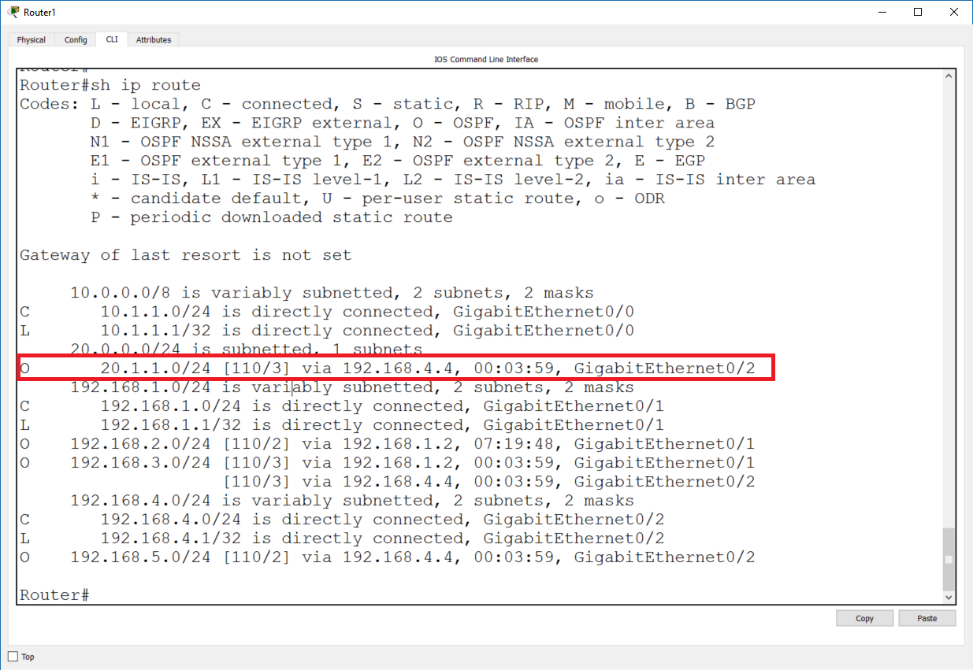

Again, have a look at the highlighted entry. This time for Router1 to reach 20.1.1.0/24 network, it will go via 192.168.4.4 (Router4). The reason: both paths are now available and the routers now about them, but this one is shorter. Remember that OSPF uses cost as its metric. The cost of each link is the same (in this situation), but there are less hops (routers) to the destination through Router4, meaning that the total cost is less and that is why this route goes into the routing table.

Note the [110/3] section – 110 is the same as before, since it is still the same protocol (OSPF) but this time the cost is 3.

Monitor the exact packet path with the same two methods as before:

1. Open the simulation mode in packet tracer, filter by ICMP and ping Laptop2 from Laptop1

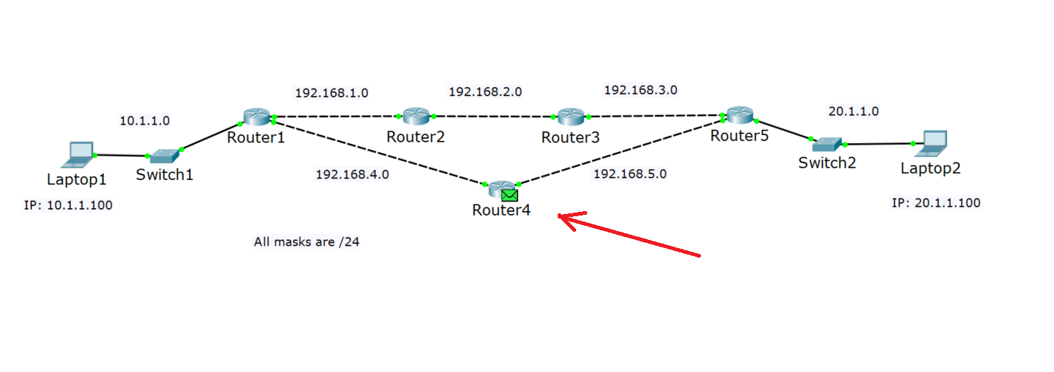

1. Use the traceroute command. From Laptop1 CMD, type **tracert 20.1.1.100**

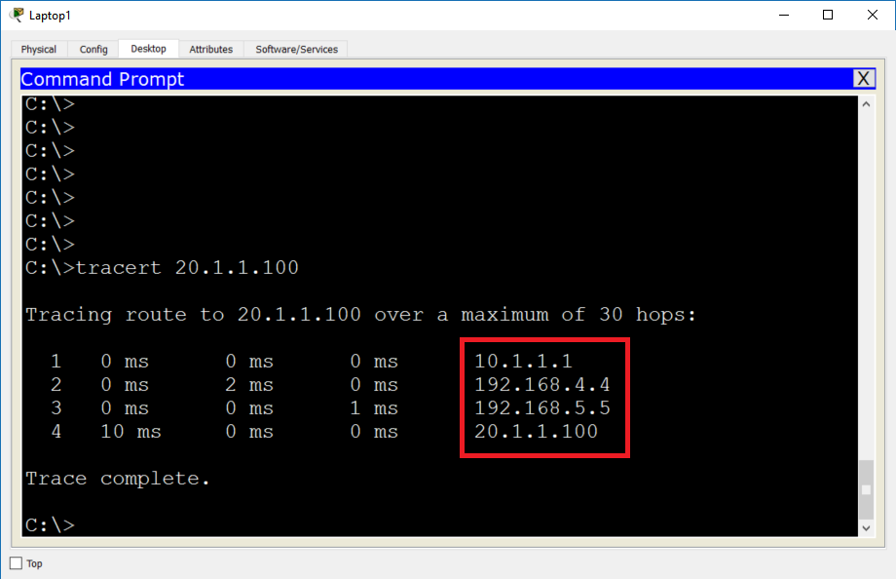

These checks prove again that the packets between Laptop1 and Laptop2 take the shortest path. It is Laptop1->Router1->Router4->Router5->Laptop2

Note: If you want to continue your tests and for example disable again OSPF between Router5 and Router4, you need to carefully check the routing tables and if there are no OSPF updates, reset the OSPF process on the routers. This is specific for the packet tracer and should not be required in a real-life situation. To reset the OSPF process, type the following command:

**clear ip ospf process**

It has to be typed from privileged mode and you have to answer with **yes** on the question Reset ALL OSPF processes? [no]: It will just restart the OSPF and it will recreate the adjacencies and the routing tables will be built correctly.

# Exercise 3: Configure passive interfaces

With this configuration OSPF is working and the packets take the most efficient path to the destination. But there is something to consider – the commands network 10.1.1.0 0.0.0.255 area 0 on Router1 and network 20.1.1.0 0.0.0.255 area 0 on Router5 not only advertise these subnets in the network, but also start sending OSPF Hello messages out of these interfaces. Since there is no one who “talks” OSPF on the other side (Switch1 and Switch2 are not OSPF enabled), these OSPF Hello messages are useless and also may represent some security issues. In this exercise, you will configure the routers not to send the hello messages out of these interfaces.

1. Configure Router1:

**router ospf 1**

**passive-interface gigabitEthernet 0/0** (this is the port-to-Switch1, in your topology may be different interface)

1. Configure Router5:

**router ospf 1**

**passive-interface gigabitEthernet 0/2** (this is the port-to-Switch2, in your topology may be different interface)

You have completed LAB 5.

# Useful commands for checking your configurations and troubleshooting

* **tracert** (Windows command) – checks the connectivity to a destination and shows the number of hops (routing devices) on the way
* **traceroute** (router command) – checks the connectivity to a destination and shows the number of hops (routing devices) on the way
* **show ip route** (router command) – shows the routing table
* **show ip ospf neighbor** (router command) – shows the OSPF neighbors
* **clear ip ospf process** (router command) – resets the OSPF process